WEEK-5

Creating Microservices for account and loan

In this hands-on exercise, we will create two microservices for a bank. One microservice for handling accounts and one for handling loans.

Each microservice will be a specific independent Spring RESTful Webservice maven project having its own pom.xml. The only difference is that, instead of having both account and loan as a single application, it is split into two different applications. These web services will be a simple service without any backend connectivity.

**Account Microservice**

Create a folder with the employee id in the D: drive

• Create a folder named 'microservices' in the new folder created in

the previous step. This folder will contain all the sample projects that we will

create for learning microservices.

• Open https://start.spring.io/ in browser

• Enter form field values as specified below:

o Group: com.cognizant

o Artifact: account

• Select the following modules

o Developer Tools > Spring Boot DevTools

o Web > Spring Web

• Click generate and download the zip file

• Extract 'account' folder from the zip and place this folder in the

'microservices' folder created earlier

• Open command prompt in account folder and build using mvn clean

package command

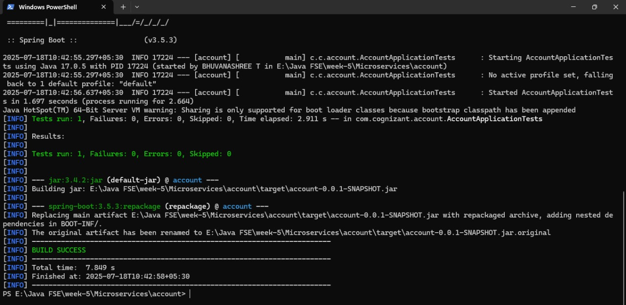

Import this project in Eclipse and implement a controller method for

getting account details based on account number

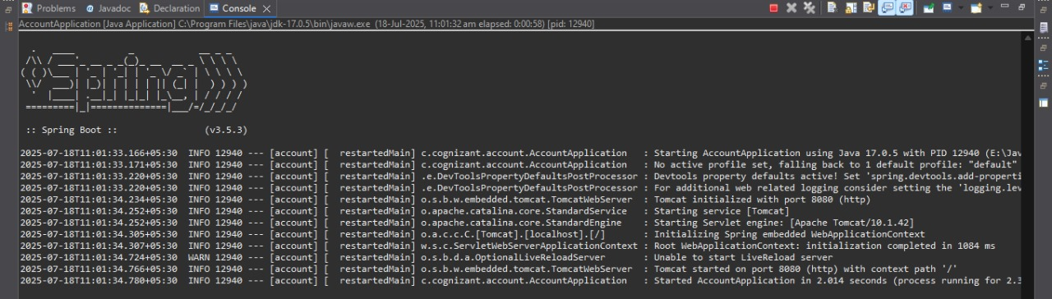

• Launch by running the application class and test the service in browser



**Loan Microservice**

Follow similar steps specified for Account Microservice and implement a

service API to get loan account details

o Method: GET

o Endpoint: /loans/{number}

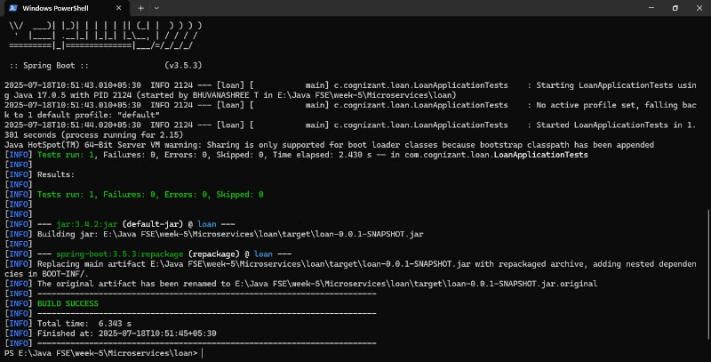

Launching this application by having account service already running

• This launch will fail with error that the bind address is already in use

• The reason is that each one of the service is launched with default port

number as 8080. Account service is already using this port and it is not

available for loan service.

• Include "server.port" property with value 8081 and try launching the

application

• Test the service with 8081 port

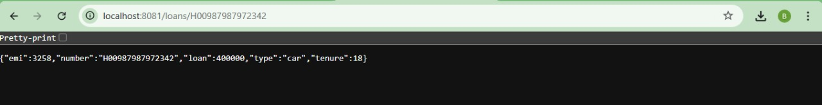

Now we have two microservices running on different ports.

